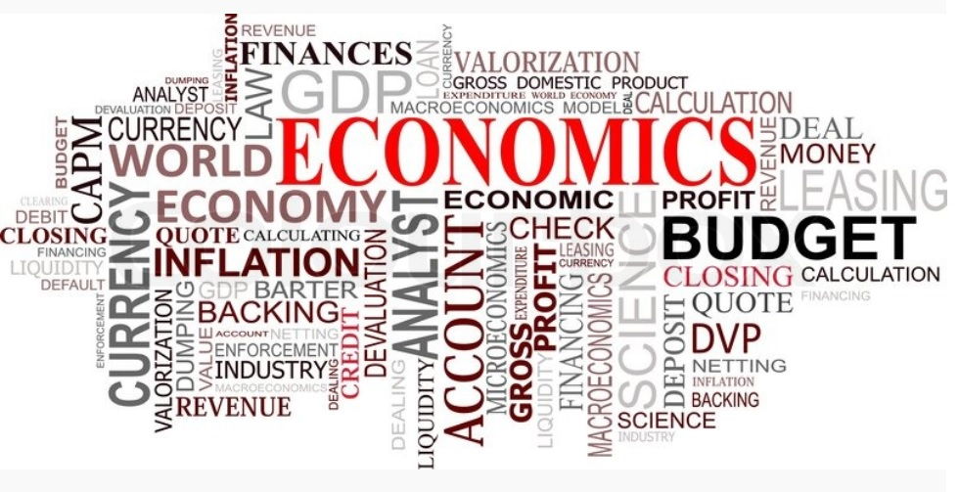

Course : commerce

Subject: principle of economics

Monthly fee: 6000

1st year